Write an application that calculates and displays the weekly salary for an employee. Create a class employee to consist of the following information: -

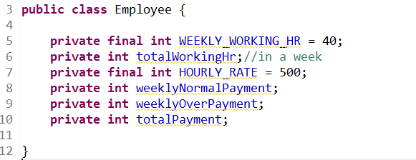

Constructor and getters & setters are used to get & set the data from the user.

calculateSalary() is used to calculate weekly salary, calculated in two ways.

* Normal rates are applicable for the regular hours.
* For overtime hours rate will be 1.5 times to the original one.

calculateSalary() method returns the total weekly salary, which is the sum of both normal & overtime salary.

Class should have display () to display the result.

**Sample Output**

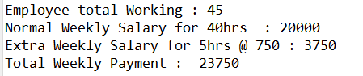

*Note: Employee total Weekly working hours should be inserted by the user (as accountant)*